MY 4-H CLOVERBUD

RECORD BOOK
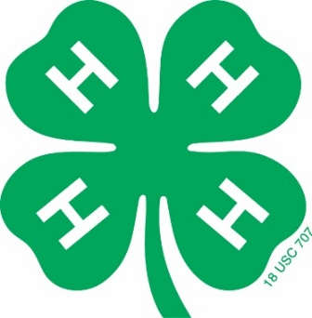

_____________________________________________
Project
Name: __________________________________
4-H Club: _______________________________
Age: __________ Birthdate: _____________
Address: ________________________________
________________________________
4-Hers Signature: ________________________
Parent/Guardian Signature: ________________
4-H Club Leader Signature: ________________
Dear 4-Hers and Helper,
This Project Record form is designed to help a young child record and recognize their accomplishments. Any help that a child receives from a parent, volunteer, or any other adult is a very positive addition to the project and the project record form as long as the child is encouraged to do as much as possible themselves. If needed, the writing can be dictated to the helper. If more space is needed, add extra sheets of paper. Good Luck!

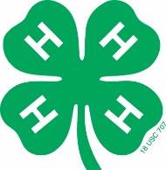
Things I learned and did in my project:
(examples)
Foods Project – Learned to measure dry ingredients March 5th
Outdoor Project - Went on a nature hike and saw two different kinds of birds September 15th

My 4-H Story
My Name is:
My favorite part of this 4-H Project was:
The hardest part about my 4-H Project was:

The Funniest part about my 4-H Project was:

Something else I want you to know about my 4-H Project is:
Who Helped you with this 4-H Project:

Other 4-H activities that I enjoyed were:

Draw a picture of something you did in your project

List any leadership activities you have participated in.
(examples: led pledge at club meeting)

_____________________________________________
__________________________________________________________________________________________
_____________________________________________
_____________________________________________
List any community service activities you have participated in.
(examples: helped clean up at the city park)
_____________________________________________
__________________________________________________________________________________________
_____________________________________________
_____________________________________________

List any citizenship activities you have participated in.
(examples: led American pledge for a club meeting)
_____________________________________________
__________________________________________________________________________________________
_____________________________________________
_____________________________________________

Other things I have done in 4-H this year:
(examples)
- Attended 8 club meetings, camp, Summer Fun, etc.
- Participated in Pumpkin-Palooza
_____________________________________________
__________________________________________________________________________________________
_____________________________________________
__________________________________________________________________________________________
__________________________________________________________________________________________
_____________________________________________
_____________________________________________
_____________________________________________
__________________________________________________________________________________________
_____________________________________________
_____________________________________________

Attach two photographs showing you working in this project.
Write a caption underneath each picture telling what is happening.
(If you would like, you may add 2 additional pages of items that show how much you have done in 4-H this
year. It might be photos or you working on your project, news clippings, other drawings, collages, poems
or other things. Make sure that what you include is related to what you do in 4-H. Be creative.)

