New Hanover County 4-H is pleased to offer fresh fragrant wreaths to you in time for the Holidays. Each wreath is handmade from the boughs of North Carolina grown Fraser Fir Christmas Trees on the Brookgreen Family Farm in Ashe County.

We are offering TWO wreath sizes.
Standard Door Wreath (20”) at $25 each
Deluxe Door Wreath (24”) at $35 each

9th Annual
New Hanover County 4-H

Wreath Sale
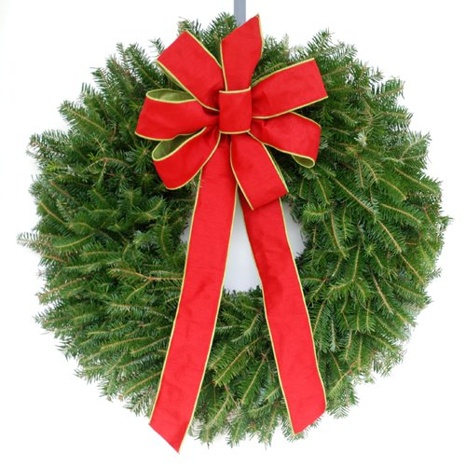
- Reserve your wreath today as we are accepting PRE-ORDERS ONLY

- Pick-up Dates:
November 24th & 25th
November 30th thru December 4th

- Pick-up Site: New Hanover County Cooperative Extension Office 6206 Oleander Dr. Wilmington, NC 28403

- Questions? Call 910-798-7660

Give the gift to your community by supporting
PRE-ORDERS DUE: Thursday, November 12, 2020
Payment Method: Check - *Credit Card
the 4-H program

# of 20” Wreath ____x $25 ea. = $______ # of 24” Wreath ____x $35 ea. = $______ TOTAL: $_____

Purchased by: _______________________________________ Phone: __________________________

Address: _____________________________________________________________________________________

City, State, Zip: ________________________________________________________________________

Email: __________________________________________ Sold by: ______________________________
(4-H member name & 4-H Club)

Is this your first time purchasing a wreath from NHC 4-H? ___ Yes ___ No (if No, how many years ______________ )

Please make check payable to: New Hanover County

OFFICE USE ONLY==========================================================================================
PAID BY: Check # ________ *Credit Card ________ (Visa, MasterCard, AMX, Discover)
Order form & check payment can be mailed to OR delivered in person at 6206 Oleander Drive, Wilmington, NC 28403
*Credit Card payments ONLY in-person at the New Hanover County Extension Office

